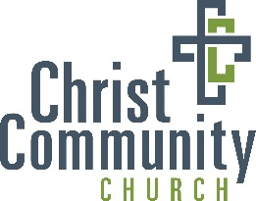

Instructions for Support Letter
- Create a list of people, and get their addresses
- Make sure the letter says what you want it to say, has your name at the bottom, and sign it
- Some of your money that you raise will go towards helping cover the cost of mailing these letters: envelopes, labels, printing, and stamps. If you want to take advantage of this, you will need to notify us of how we can help with this: how many labels & envelopes you need, send us your letter and let us know how many copies you need, etc…
- To each person, send:
  - Letter
  - Supporter Response Card – YOU fill out the bottom right part of the form BEFORE you send it: It’s your address so your supporters know who to send it back to
  - Self-Addressed Envelope (folded up) – put your address on front
- When you receive responses, you need to keep track of:
  - Information for each supporter (address, e-mail, prayer and/or $ support)
  - How much they gave (if they gave money)
  - A running total of the amount you have raised
- Turn in the check/money to Lorinda & you keep the Response Card
- When we return from Mexico, you will be expected to send a letter to your supporters re-capping the trip
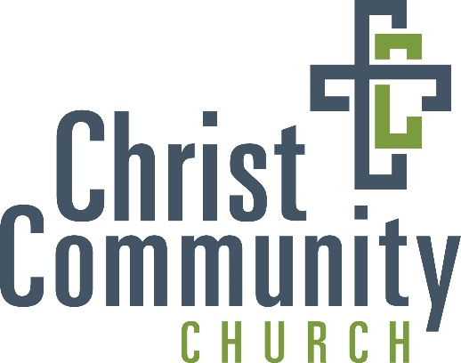

Dear Friends and Family,

In July 2019, I am planning on going to Ensenada, Mexico with the Student Ministries of Christ Community Church. Our group of 9-12th graders will be serving alongside with YUGO Ministries for about a week.

YUGO is a ministry that is concerned with giving students active participation in missions efforts, being Biblically centered, and striving for excellence and innovation. They provide a great mutli-cultural experience, excellent training, and whole-heartedly believe in the power of the Gospel to transform lives, and a city. Through trips like these, we hope to help students discover how they can use their gifts and passions to partner with the work of God in the world. They should understand that all gifts, abilities, and vocations can be used to make God known.

The purpose of this trip is to help us discover how we can use our gifts to partner with what God is doing globally, expose us to a different culture, and experience missions in another country. In order to accomplish this first task, we will be working with the YUGO team to find a match between our teams’ gifts and their needs. While we are there we will be working to construct a home for a family and running a children’s program. All that we do will fall into the category of: PRAYING for God to be at work in lives, CARING for people’s needs, or SHARING the Gospel with our words and actions.

Primarily, would you consider supporting me, our team, and the YUGO team with prayer? We are also raising money for the trip and would appreciate donations of any amount. The cost of traveling from Ames to Mexico and serving for a week is $1,100 per person. Any additional funding will be used to meet any vital needs of YUGO. If you feel lead to support in this way, please return the enclosed card by April 15th, 2019.

Blessings to you and your family,

(Sign your name here)
Your name

